Arturia Analog Experience The Laboratory – Default CC Mappings

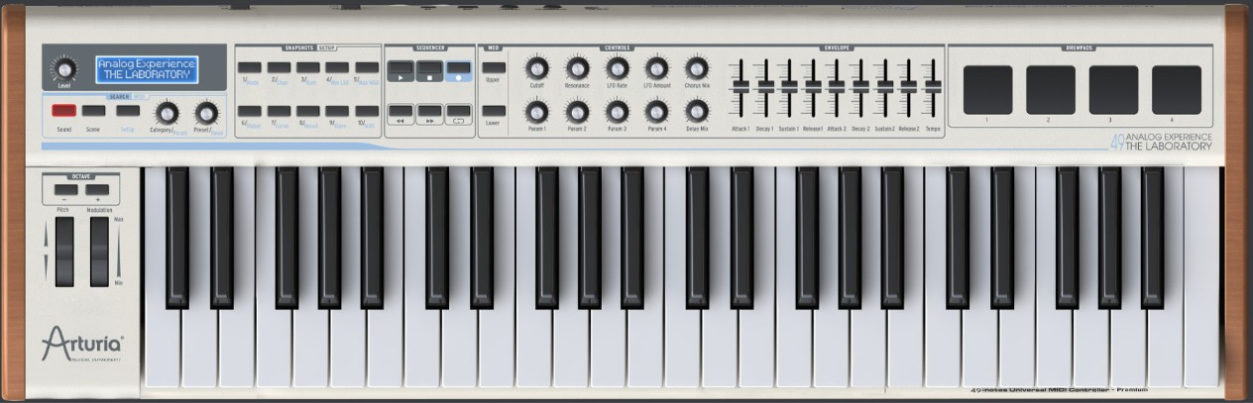

83

82

81

85

80

72

79

75

91

73

17

16

19

18

93

77

71

74

76

G8

F#8

F8

E8

C5

C1

7

1

PB

46

47

55

54

53

51

52

50

28

31

30

29

27

26

24

25

26

25

24

25

26

24

24

25

26

23

23

24

25

26

22

114

115

112

113

118

119

|  |  |  |  |
| --- | --- | --- | --- |
| MIDI | Label | Name | Value |
| Pitch Bend | Pitch |  | 0..8192..16383 (14 bit) |
| Note On/Aftertouch/Off 124..127 | Drumpads 1..4  (Keys E8..G8) | DrumPad1..4 | 0..127 |
| Note On/Channel Aftertouch/Off 24..60 | Keys C1..C5 |  | 0..127 |
|  |  |  |  |

|  |  |  |  |
| --- | --- | --- | --- |
| CC ID | Label | Name | Value |
| 1 | Modulation | ModWheel (Modulation Wheel) | 0..127 |
| 7 | Level | LevelEnc (Channel Volume) | 0..127 |
| 16 | Param 3 | KeyParm3 (General Purpose Ctrl 3) | 0..127 |
| 17 | Param 4 | KeyParm4 (General Purpose Ctrl 4) | 0..127 |
| 18 | Param 1 | KeyParm1 (General Purpose Ctrl 1) | 0..127 |
| 19 | Param 2 | KeyParm2 (General Purpose Ctrl 2) | 0..127 |
| 22..31 | Snapshots 1/ .. /10 | SnapSht1..10 (Undefined) | 0/127 |
| 46/47 | Lower/Upper | PnlLower/Upper (Undefined) | 0/127 |
| 50..55 | Start/Stop/Record Backward/Forward/Loop | HostCtl1..6 (General Purpose LSB / Undefined) | 0/127 |
| 71 | Resonance | FiltReso (Timbre/Harmonic) | 0..127 |
| 72 | Release 1 | SldrRel1 (Release Time) | 0..127 |
| 73 | Attack 1 | SldrAtt1 (Attack Time) | 0..127 |
| 74 | CutOff | FiltFreq (Brightness) | 0..127 |
| 75 | Decay 1 | SldrDec1 (Decay Time) | 0..127 |
| 76 | LFO Rate | LFO Rate (Vibrato Rate) | 0..127 |
| 77 | LFO Amount | LFO Amnt (Vibrato Depth) | 0..127 |
| 79 | Sustain 1 | SldrSus1 (Sound Ctrl 10) | 0..127 |
| 80 | Attack 2 | SldrAtt2 (General Purpose Ctrl 5) | 0..127 |
| 81 | Decay 2 | SldrDec2 (General Purpose Ctrl 6) | 0..127 |
| 82 | Sustain 2 | SldrSus2 (General Purpose Ctrl 7) | 0..127 |
| 83 | Release 2 | SldrRel2 (General Purpose Ctrl 8) | 0..127 |
| 85 | Tempo | SldrTmpo (Undefined) | 0..127 |
| 91 | Delay Mix | Mix Delay (Reverb Level) | 0..127 |
| 93 | Chorus Mix | Mix Chorus (Chorus Level) | 0..127 |
| 112 | Category | CategEnc | 1/65 |
| 113 | Category | CategBtn | 0/127 |
| 114 | Preset | PresetEnc | 1/65 |
| 115 | Preset | PresetBtn | 0/127 |
| 118 | Sound | SoundMod | 0/127 |
| 119 | Scene | SceneMod | 0/127 |